UML Diagrams

1. Component Diagram

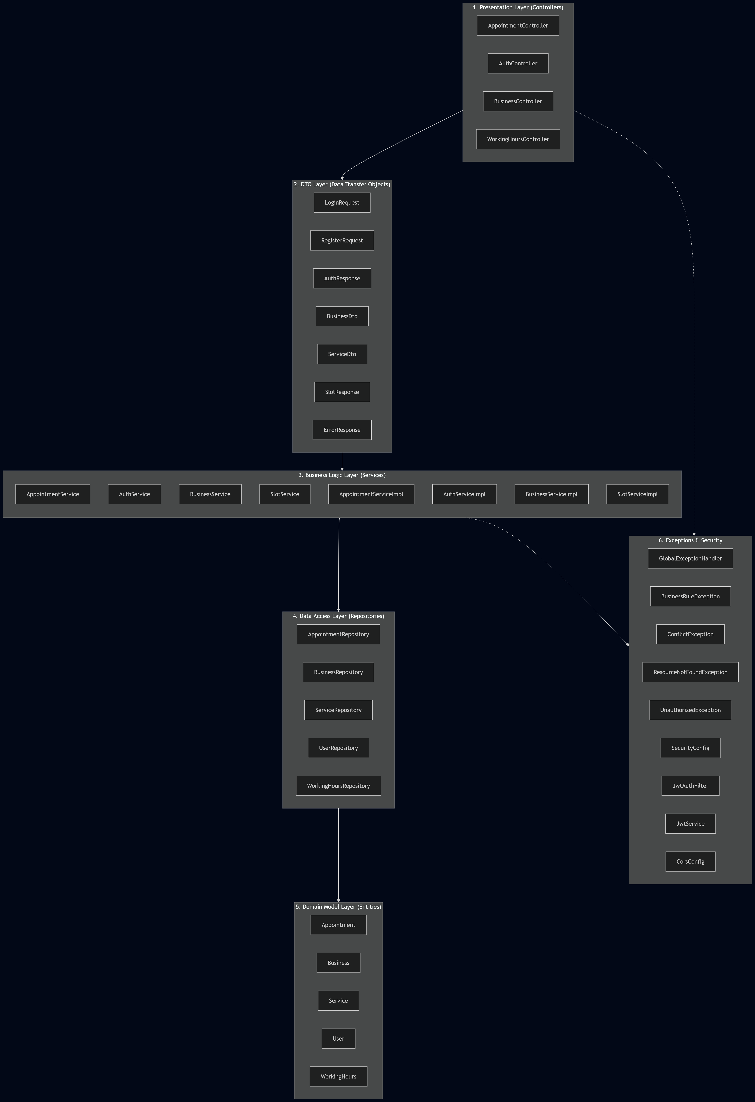
2. Exhaustive Layered Architecture Diagram
2.1. Presentation Layer
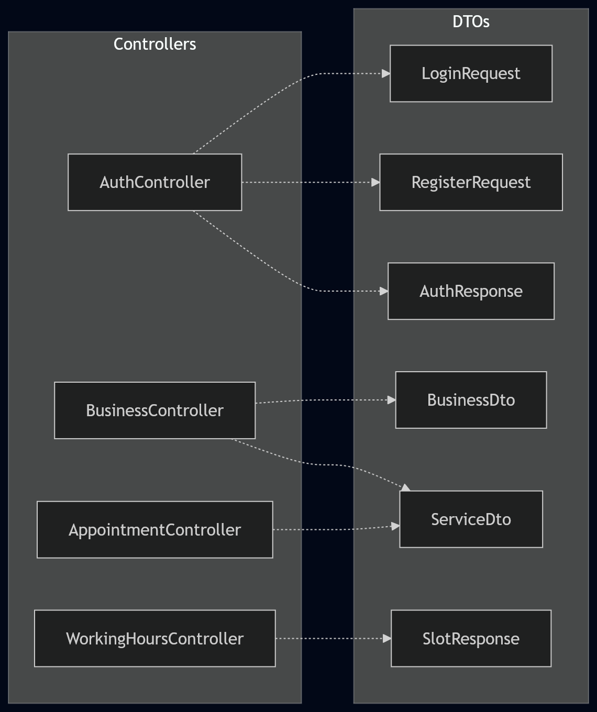

2.2. Business Logic Layer
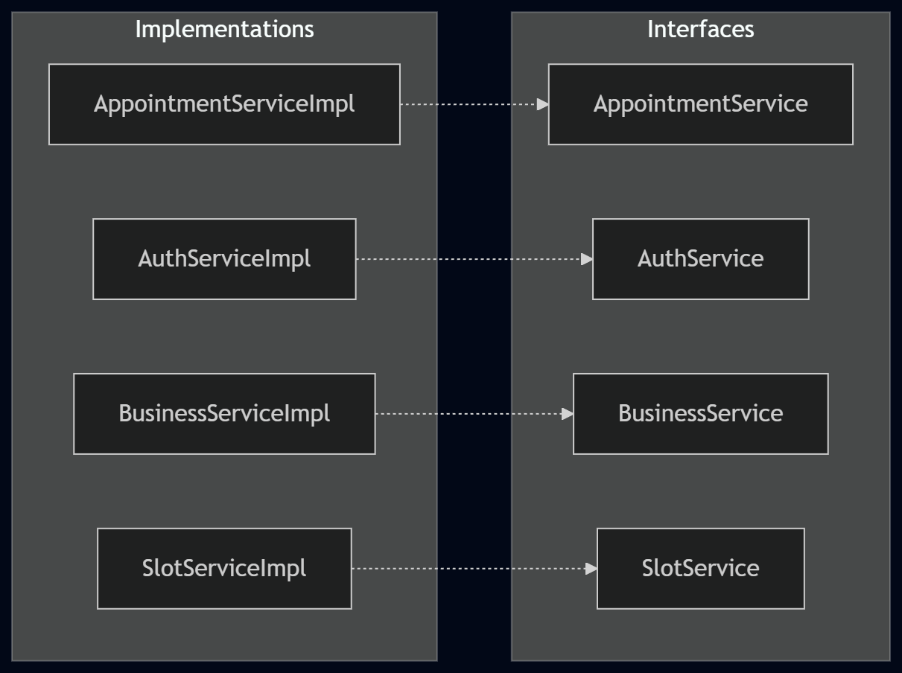

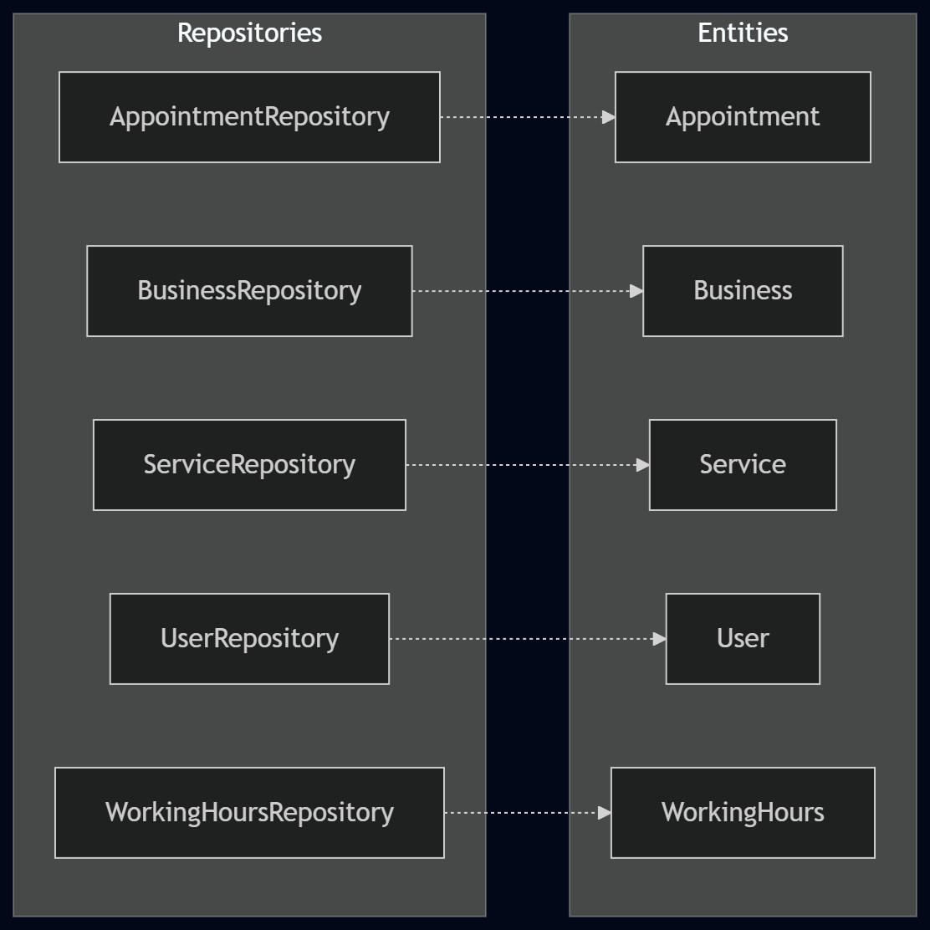
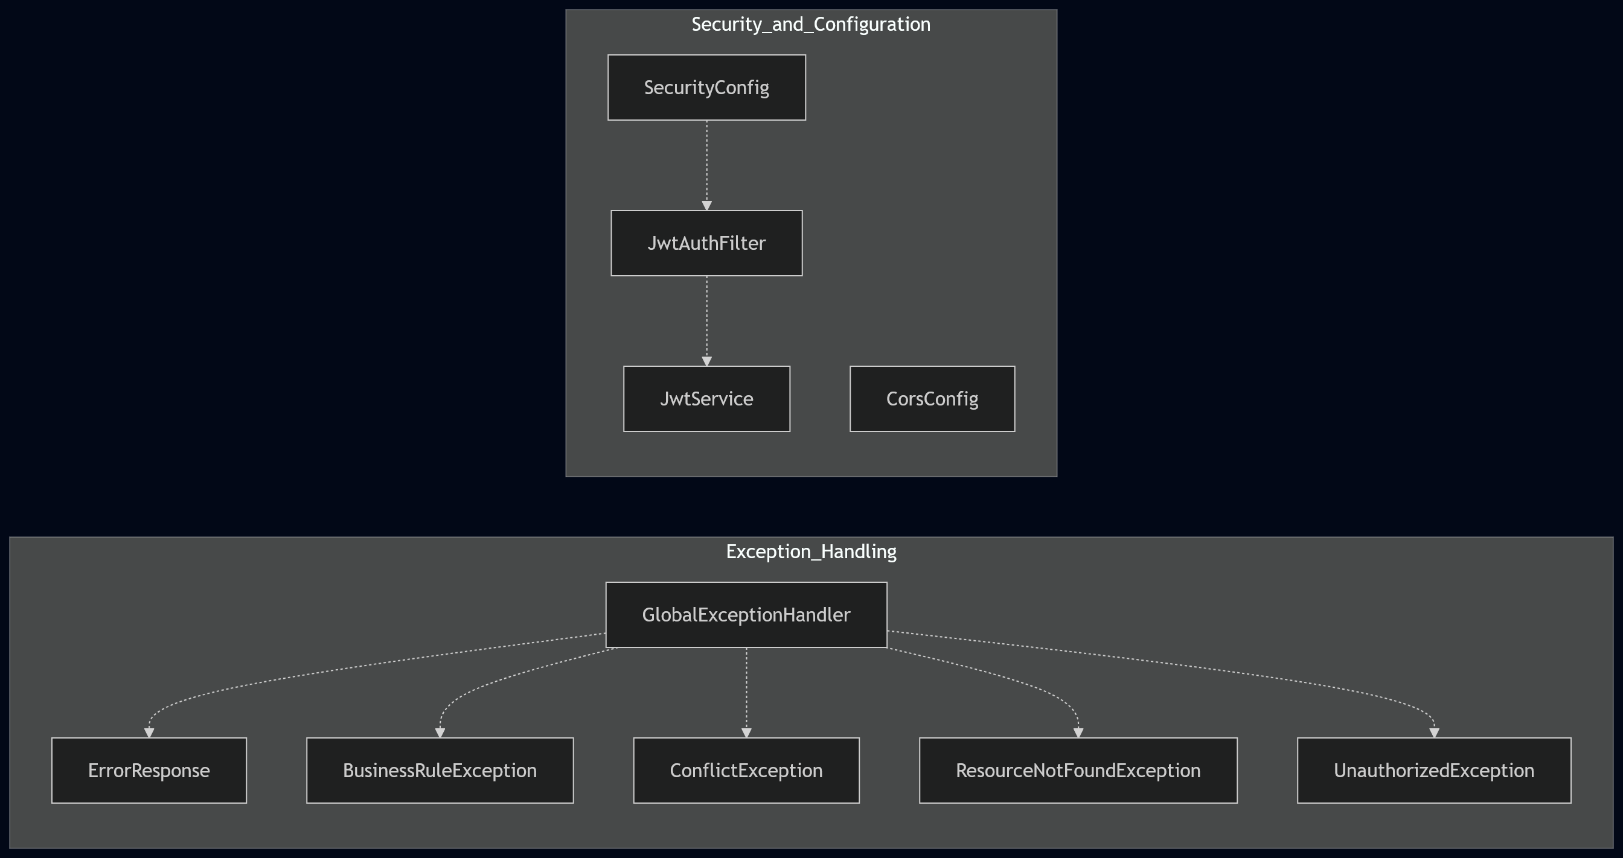
2.3. Data Access & Domain Layer
2.4. Security, Config & Exception Handling
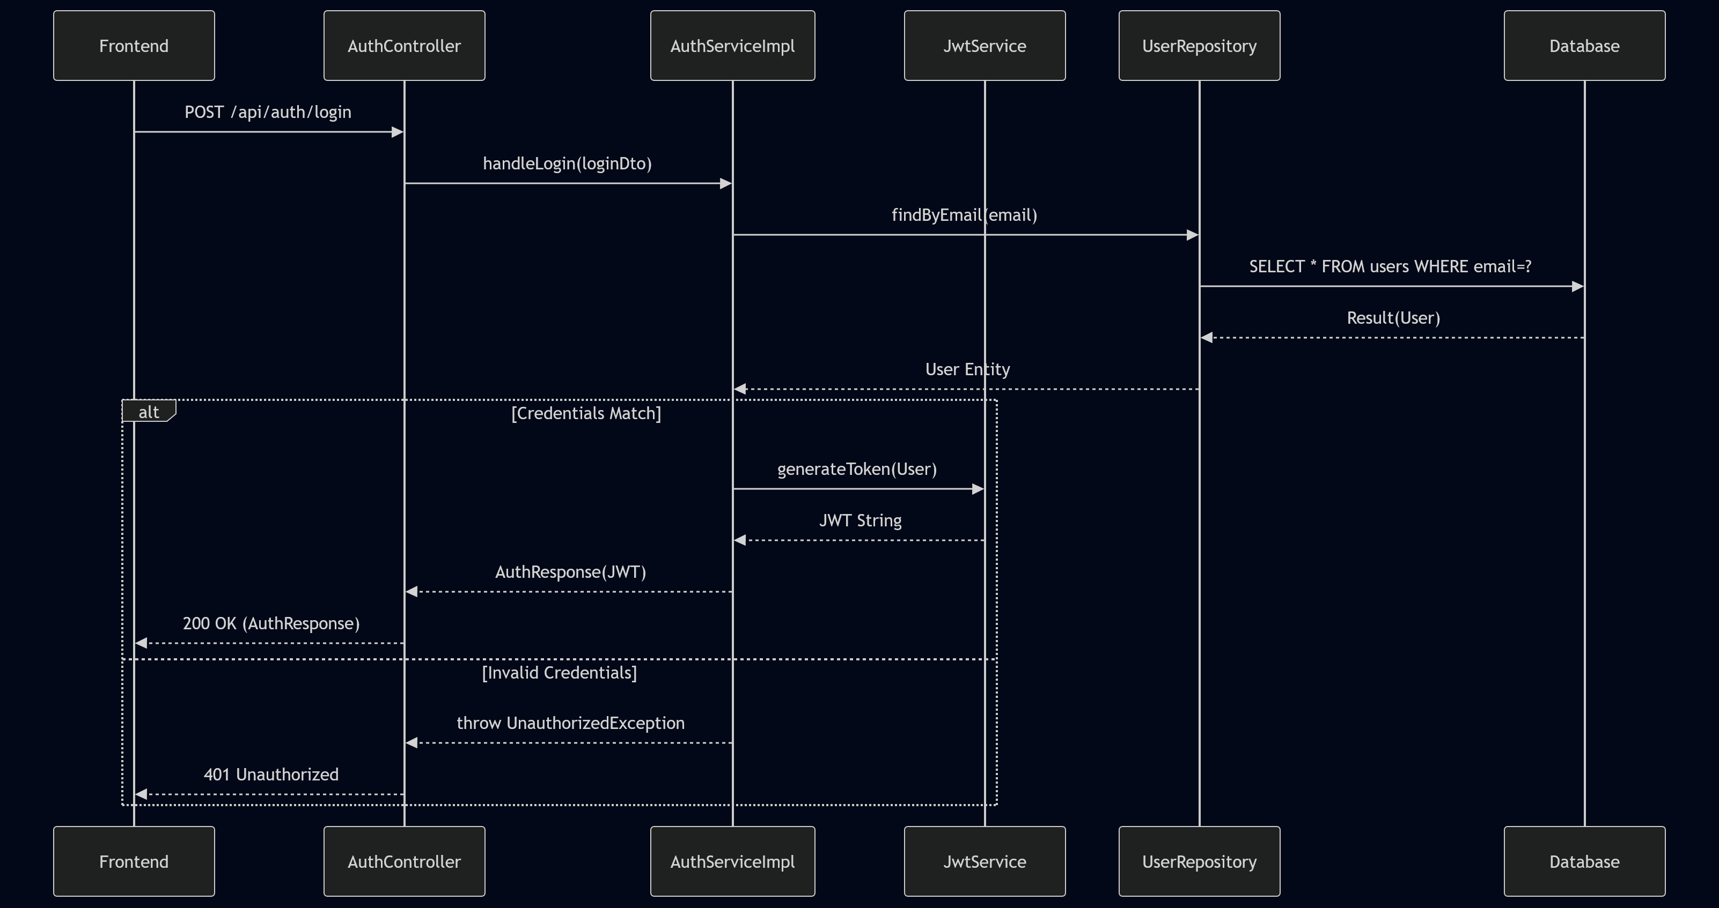
3. Sequence Diagram (JWT Authentication)
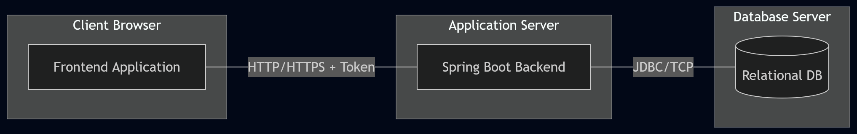

4. Deployment Diagram

